FY 22 Annual Report

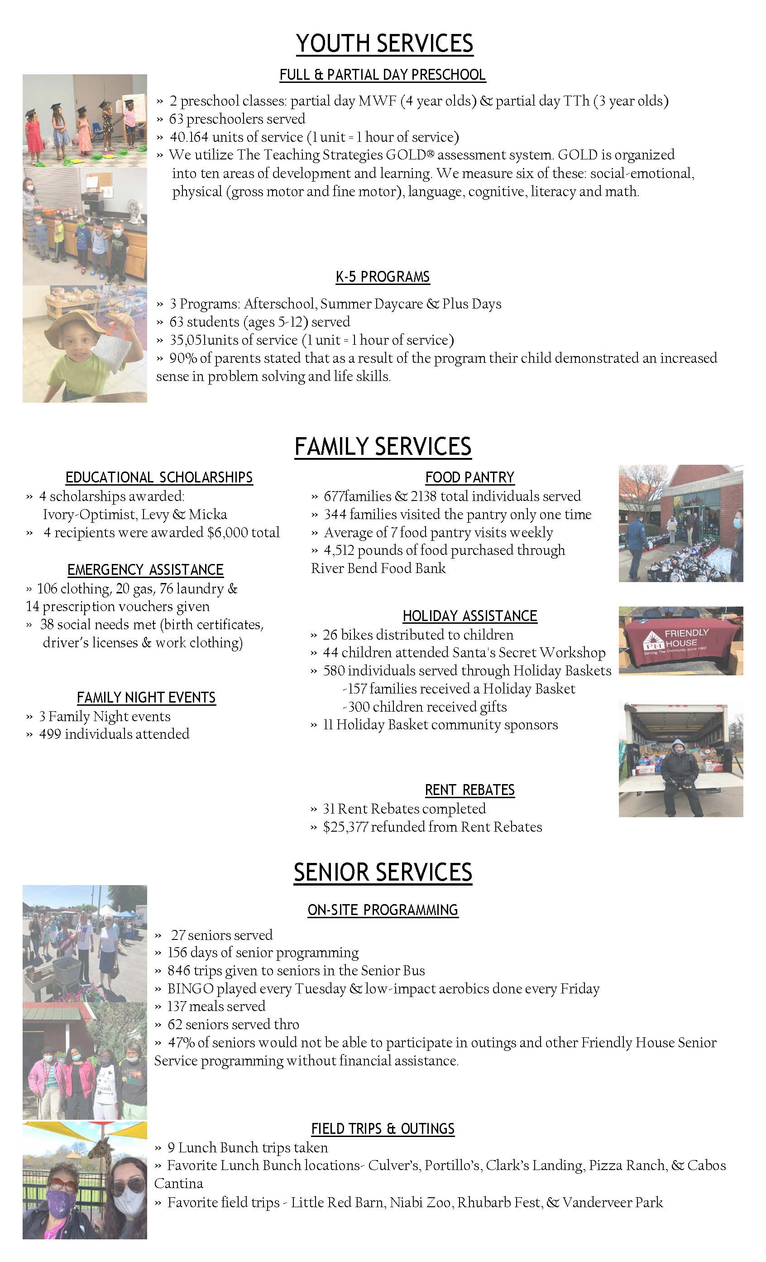
2021-2022 Board of Directors

Jim Farber- President
Andy Erpelding- Vice President
Mike Goben - Secretary
Chris Koerperich- Treasurer

Becky Eiting
Rob Frieden
Beth Hancock
Andrew Harris
John Kessler
Brett Ketelsen
Bailey Krieger
Greg Larrison
Doug McDonald
Erin McKay
Paul Neuharth
John Oliger
Jennifer Randazzo
Dan Riefe
Chris Shumpert
Beth Tinsman
Andy Trasowech
Tom Wagner
Bob Waterman
Doug Wier
Marcus Wynn

FY22 Financials

